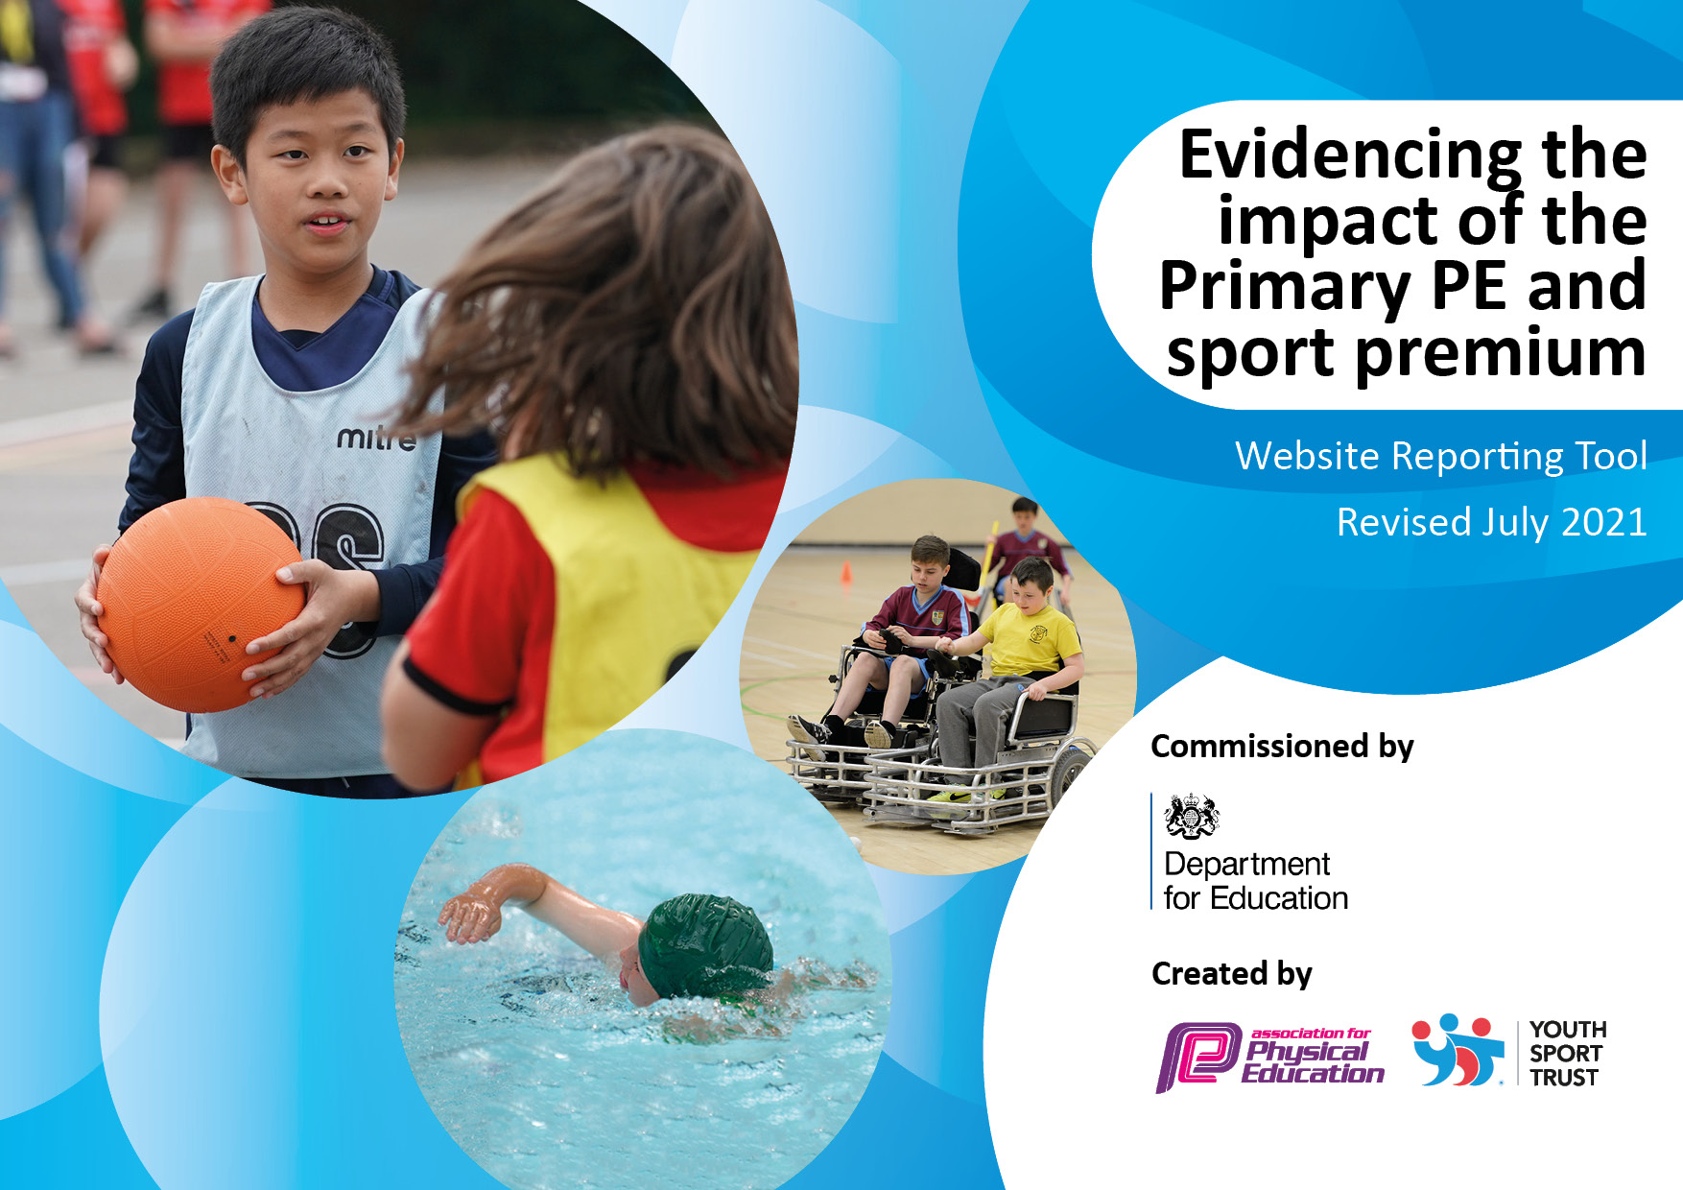
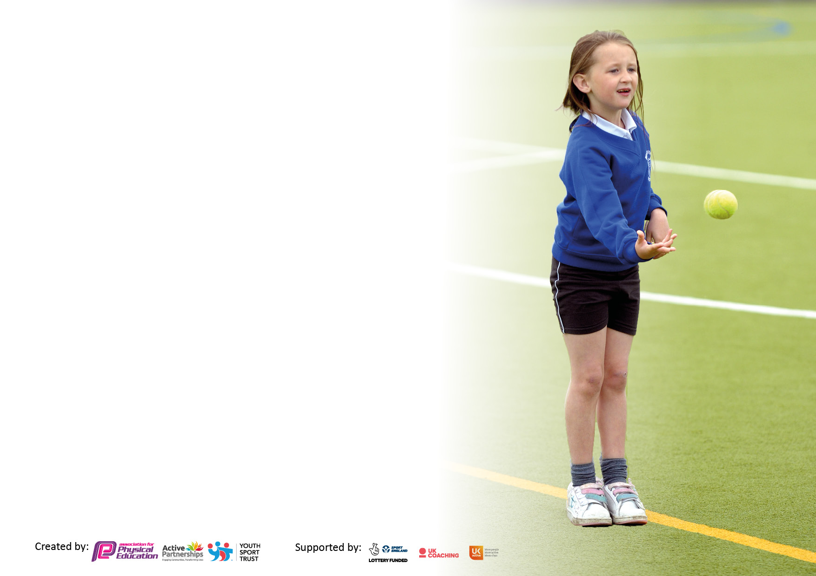

It is important that your grant is used effectively and based on school need. The Education Inspection Framework makes clear there will be a focus on ‘whether leaders and those responsible for governors all understand their respective roles and perform these in a way that enhances the effectiveness of the school’.

Under the Quality of Education Ofsted inspectors consider:
Intent - Curriculum design, coverage and appropriateness
Implementation - Curriculum delivery, Teaching (pedagogy) and Assessment
Impact - Attainment and progress

To assist schools with common transferable language this template has been developed to utilise the same three headings which should make your plans easily transferable between working documents.

Schools must use the funding to make additional and sustainable improvements to the quality of Physical Education, School Sport and Physical Activity (PESSPA) they offer. This means that you should use the Primary PE and sport premium to:

- Develop or add to the PESSPA activities that your school already offer
- Build capacity and capability within the school to ensure that improvements made now will benefit pupils joining the school in future years
- The Primary PE and sport premium should not be used to fund capital spend projects; the school’s budget should fund these.

Pleasevisitgov.ukfortherevisedDfEguidanceincludingthe5keyindicatorsacrosswhichschoolsshoulddemonstrate animprovement.Thisdocumentwillhelpyoutoreviewyourprovisionandtoreportyourspend.DfEencouragesschools to use this template as an effective way of meeting the reporting requirements of the Primary PE and sport premium.

We recommend you start by reflecting on the impact of current provision and reviewing the previous spend.

Schools are required to publish details of how they spend this funding, including any under-spend from 2019/2020, as well as on the impact it has on pupils’ PE and sport participation and attainment. All funding must be spent by 31st July 2022.

We recommend regularly updating the table and publishing it on your website throughout the year. This evidences your ongoing self-evaluation of how you are using the funding to secure maximum, sustainable impact. Final copy must be posted on your website by the end of the academic year and no later than the 31st July 2021. To see an example of how to complete the table please click HERE.
Created by: Supported by:

Details with regard to funding
Please complete the table below.

Total amount carried over from 2019/20 | £18,610
Total amount allocated for 2020/21 | £18,640
How much (if any) do you intend to carry over from this total fund into 2021/22? | £2500 – Covid-19 underspend
Total amount allocated for 2021/22 | £18,600+£2,500= £21,140
Total amount of funding for 2021/22. To be spent and reported on by 31st July 2022. | £21,140  - £19,443 was spent when I was in school  - In my absence £1,697 was spent on coach travel; equipment and supply cover by the appropriate staff covering on my behalf.
Total amount of funding for 2022-2023. To be spent and reported on by 31st July 2023. | £18,520
Swimming Data
Please report on your Swimming Data below.

Meeting national curriculum requirements for swimming and water safety.  N.B. Complete this section to your best ability. For example you might have practised safe self-rescue techniques on dry land which you can then transfer to the pool when school swimming restarts.  Due to exceptional circumstances priority should be given to ensuring that pupils can perform safe self rescue even if they do not fully meet the first two requirements of the NC programme of study | 50%
What percentage of your current Year 6 cohort swim competently, confidently and proficiently over a distance of at least 25 metres?  N.B. Even though your pupils may swim in another year please report on their attainment on leaving primary school at the end of the summer term 2021.  Please see note above | 50%
What percentage of your current Year 6 cohort use a range of strokes effectively [for example, front crawl, backstroke and breaststroke]?  Please see note above | 20%
What percentage of your current Year 6 cohort perform safe self-rescue in different water-based situations?
Schools can choose to use the Primary PE and sport premium to provide additional provision for swimming but this must be for activity over and above the national curriculum requirements. Have you used it in this way? | No

Action Plan and Budget Tracking
Capture your intended annual spend against the 5 key indicators. Clarify the success criteria and evidence of impact that you intend to measure to evaluate for pupils today and for the future.

Academic Year: 2022-2023 | Total fund allocated: £18,520 | Date Updated: 09.11.22
Key indicator 1: The engagement of all pupils in regular physical activity – Chief Medical Officers guidelines recommend that primary school pupils undertake at least 30 minutes of physical activity a day in school |  |  |  | Percentage of total allocation:
 |  |  |  | 16 %
Intent | Implementation |  | Impact
Your school focus should be clear what you want the pupils to know and be able to do and about  what they need to learn and to  consolidate through practice: | Make sure your actions to achieve are linked to your intentions: | Funding allocated: | Evidence of impact: what do pupils now know and what can they now do? What has changed?: | Sustainability and suggested next steps:
Hawthorn’s intent:  All sports should be inclusive. At Hawthorn, we aspire to be a school that offers an inclusive environment to ensure every child participates in sport and fulfils their full potential. PE should aim to develop a child’s physical, mental and social well-being. Therefore, our aim is for our children to understand and enjoy what a healthy life style means; enabling them to grow into confident, well-rounded and healthy young adults.  Key goal at Hawthorn – two year programme – to support the impact from Covid-19. Raising attainment in primary school swimming to meet requirements of the national curriculum before the end of key stage 2 - every child should leave primary school able to swim  To continue providing targeted activities or support to involve and encourage the least active children. | - Every child will receive their two PE lessons at week now restrictions have been lifted.  - Morning and after school clubs delivered by experienced staff members – Finding Fitness. Offered to all of KS1 and KS2. They are also offering gross motor interventions to support the EYFS chd.  - Year 6 sports crew every Tuesday and Thursday  - PE curriculum map 22-23.  - Lunch time activities promoted through sports crew and Fiesta Sports  - All KS2 children to have the opportunity to swim. | Pe hub subscription (identified in indicator 4)  Finding Fitness (identified in indicator 3)  Fiesta sports (identified in indicator 3)  £3,010 swimming transport | Every child has a two-hour slot timetabled for PE each week – including swimming lessons for years 3-6 and various sports clubs. The children receive high quality teaching from teachers and specialist teachers using the PE hub. Progression is developed through the key stages and a broad and balanced curriculum is offered – as seen in curriculum map. Knowledge end points for each unit and year group have done been completed. Supporting teachers’ and children’s understanding of what is expected within the unit.  Before and after school clubs take place in line with planned events. Children participate in various sports, which are taught by specialist teachers.  Sports crew -Year 6 children hold a lunch time activity (sport related) to all children every Tuesday and Thursday. This is monitored by a member of staff and is regularly changed to provide various activities to all.  Lunch time supervisors have a responsibility to provide a range of activities at lunch time. The children have loved participating in the dance classes and football Fridays.  - Swimming catch up programme will target the year 5 and 6 children who has missed out on the opportunity to swim these past two years.  - Improving 25m % pass rate from 2020-2021 (64% year 6 could swim). Last year it dropped to 56.52%, so it is evident that these extra swimming lessons are provided to all of KS2.  - Introducing swimming at an earlier age (year 3 and 4) to help reduce the % of those leaving year 6 unable to swim 25m.  - In 2023-2024, the aim will be to provide sessions only to years 3 ad 4 with a catch-up programme in term 6 for years 6 only. | £3010 spent on transport for swimming
Key indicator 2: The profile of PESSPA being raised across the school as a tool for whole school improvement |  |  |  | Percentage of total allocation:
 |  |  |  | 10%
Intent | Implementation |  | Impact
Your school focus should be clear what you want the pupils to know and be able to do and about  what they need to learn and to  consolidate through practice: | Make sure your actions to achieve are linked to your intentions: | Funding allocated: | Evidence of impact: what do pupils now know and what can they now do? What has changed?: | Sustainability and suggested next steps:
“actively encourage pupils to take on leadership or volunteer roles that support the delivery of sport and physical activity within the school (such as ‘sports leader’ or peer-mentoring schemes)”  “embedding physical activity into the school day through encouraging active travel to and from school, active break times and holding active lessons and teaching”  Providing targeted activities or support to involve and encourage the least active children. | Providing training for sports crew to deliver sports effectively. Application and initial meeting to ensure sensible, reliable and passionate candidates are chosen.  Bike ability – Encouraging active travel to school as part of children’s 60 minute a day intake.  Increased hours of FF to provide additional before and after school clubs.  New coaches to provide further experiences and knowledge for our Hawthorn children. | Bikeability (identified in indicator 4)  Staff training (lunch time supervisors) to support with sports crew identified in indicator 3.  Finding Fitness identified in indicator 3. | Sports crew -Year 6 children hold a lunch time activity (sport related) to all children every Tuesday and Thursday. This is monitored by a member of staff and is regularly changed to provide various activities to all. There has been a huge intake of children this year which is incredibly positive.  Bikeability encourages the children in the local area to actively travel to school. Road safety awareness also reassures and promotes parents to push for active travel too. This has taken place in Term 2.  KS1 children continue to have more opportunities this year to take part in before or after school clubs due to our sports coaches. This supports the children with any upcoming planned events and allows the to experience a wider PE curriculum. | £264 used for Bikeability

Key indicator 3: Increased confidence, knowledge and skills of all staff in teaching PE and sport |  |  |  | Percentage of total allocation:
 |  |  |  | 50 %
Intent | Implementation |  | Impact
Your school focus should be clear | Make sure your actions to | Funding | Evidence of impact: what do | Sustainability and suggested
what you want the pupils to know | achieve are linked to your | allocated: | pupils now know and what | next steps:
and be able to do and about | intentions: |  | can they now do? What has
what they need to learn and to |  |  | changed?:
consolidate through practice:
General PE equipment – health and safety audits, replenishing equipment for PE lessons and the playground.  Hiring qualified sports coaches and PE specialists to work alongside teachers to enhance or extend current opportunities offered to pupils - teachers should learn from coaches the necessary skills to be able to teach these new sports and physical activities effectively. | Finding Fitness – Provision of quality afterschool and morning activities linked to KSSP and Pathfinders’ competitions.  New and safe equipment purchased on the basis it is purposeful and refers to the long-term planning.  Staff training and CPD opportunities to enhance performance and quality of teaching.  School Games has supported PE lead’s understanding of subject and resources provided have benefitted role and understanding.  KSSP entry fee entitles school to support from specialist teachers. PE lead often has regular contact with KSSP lead to ensure best practise is in place. | £1,276 supply, staff training, transport and overtime  £1,000 resources and equipment  £800 PE equipment and H&S audits  £6,240 Finding Fitness (specialist teachers on Thursdays)  £5,180 Fiesta Sports Coaching (specialist teachers on Tuesdays)  KSSP identified in indicator 5 | Our sports coaches have been providing both morning, afternoon and lunchtime clubs to both KS1 and KS2. Many of these clubs are in line with KSSP or PF competitive events. Preparing the children, the skills and knowledge needed. Fiesta Sports also promote healthy living within their lunch-time clubs.  Having specialist teachers to come in and carry out the programme. TAs who support are gaining an insight into a purposeful PE lesson too.  KS1 children are provided with more opportunities to take part in before or after school clubs due to lunch time clubs and after schools clubs provided by sports specialists.  At the end of the year, PE lead checks and audits equipment to ensure the children are receiving a high quality PE lesson with the necessary equipment.  Staff training and CPD opportunities to enhance performance and quality of teaching.  Sports crew lead is due to receive sports coaching training to enhance his skills and knowledge to further development the activities he provides for children during lunchtimes. | £1276 used for staff training and overtime to ensure competitions attended.  £1000 spent on PE equipment  £800 for audits and H7S  £6240 spent of Finding fitness/ Fiesta Sport to provide extra curricular clubs twice a week over the year
Key indicator 4: Broader experience of a range of sports and activities offered to all pupils |  |  |  | Percentage of total allocation:
 |  |  |  | 10%
Intent | Implementation |  | Impact
Your school focus should be clear | Make sure your actions to | Funding | Evidence of impact: what do | Sustainability and suggested
what you want the pupils to know | achieve are linked to your | allocated: | pupils now know and what | next steps:
and be able to do and about | intentions: |  | can they now do? What has
what they need to learn and to |  |  | changed?:
consolidate through practice:
Bike ability/cycling provision to develop the children’s cycling skills and road safety awareness  Provision of high-quality PE planning.  Swimming to continue for all of KS2  Partnering with other schools to run sports and physical activities and clubs – PF schools and KSSP. | - Knowledge organisers established by the trust and PE hub inform and support staff delivering PE.  - Continuing to use the PE HUB to ensure progression is shown through the key stages.  - As previously mentioned in indicator 3, swimming will commence for all of KS2 to improve the overall % that leave us in year 6. | £375 PE hub subscription  £264 Bikeability  Swimming (identified in indicator 1).  KSSP entry fee identified in indicator 5 | PE hub planning is always printed for FF in an allocated place in PE lead’s room. This supports transition of PE from teacher to FF, ensuring the pupils are receiving a broad and balanced PE curriculum.  PE lead gained advice and research into current PE scheme to ensure it is purposeful and offers a broad and balanced curriculum. Other PF schools seem to be moving towards REAL PE, so this will be taken into consideration in the near future.  KSSP entry fee paid (as seen in indicator 5)  PE lead regularly meets up with other PF schools PE leads to plan events throughout the academic year | £375 spent on PE Hub for a progressive scheme of work

Key indicator 5: Increased participation in competitive sport |  |  |  | Percentage of total allocation:
 |  |  |  | 5%
Intent | Implementation |  | Impact
Your school focus should be clear | Make sure your actions to | Funding | Evidence of impact: what do | Sustainability and suggested
what you want the pupils to know | achieve are linked to your | allocated: | pupils now know and what | next steps:
and be able to do and about | intentions: |  | can they now do? What has
what they need to learn and to |  |  | changed?:
consolidate through practice:
To attend as many Kettering Schools Sports Partnership (KSSP) level 2 events – hence full payment of £375  To increase our participation in the upcoming PF schools’ competitions  Year 6 sports crew to continue  School Games participation to continue | Increasing and actively encouraging all pupils’ participation in the sport – PF schools.  PE lead to attend PF schools regular meetings to plan and contribute to upcoming events.  KSSP offer level 2 events – opportunities for your gifted and talented children. | £375 KSSP entry fee  Supply cover identified in indicator 3 – to allow PE lead to attend termly meetings. | Since entering competitions, all children have had more opportunities to take part in sport and represent the school. Competing against other schools helps promotes many interpersonal skills and a child’s own social development. This year we have chosen to pay the full amount which means we have more access to a range of competitions and levels (level 1 and 2).  PP and SEN children are given an opportunity to leave school and take part in sports events on behalf of their school.  Competitions within our own PF trust promote increased participation. These are not competitive events but are great opportunities to involve and encourage as many children as possible.  KSSP offer many CPD and club opportunities for the school. | £375 on KSSP entry fee

Signed off by
Head Teacher: | Emma Jacox
Date: | 28.7.2023
Subject Leader: | Jayne Tinto
Date: | 28.7.2023
Governor:
Date:

