Special Education Needs and Disability
(SEND) Policy

In addition to this policy, Hawthorn Primary School provides a SEND Information Report.
Hawthorn Primary - Inclusion (hawthornprimarykettering.co.uk)
Compliance
This policy complies with the statutory requirement laid out in the SEND Code of Practice (2015) and has been written with reference to the following guidance and documents:

- Equality Act 2010: advice for schools DfE Feb 2013
- SEND Code of Practice 0 – 25 (2015)
- Schools SEN Information Report Regulations (2014)
- Statutory Guidance on Supporting pupils at school with medical conditions (updated 2015)
- The National Curriculum in England Key framework document (updated 2014)
- Montsaye Academy Safeguarding Policy (2021)
- National Teachers Standards (updated 2021)
- The Children and Families Act (2014)

Section 1
Basic Information
The SENCo for Hawthorn Primary School is Frances Martin. They can be contacted via the School Office on 01536 512204 or via email: fmartin@hawthorn.pfschools.org.uk. The Education Support team consists of an Inclusion Leader/SENDCo, a Family Support Worker and Teaching Assistants who work with children with a higher level of need on a 1:1 basis or in a small group.
Frances Martin completed and passed the National Award for SEN in July 2017.
The member of Hawthorn Primary School with responsibility for SEND is Frances Martin.
The SEND Governor for the school is Catherine Adams.
Hawthorn Primary School is a mainstream academy and is open to students aged 4-11 years old. The academy is located in Kettering. Many of the students that attend Hawthorn Primary School travel from the local area.
The school ethos is ‘cultivating the futures of our children,’ that reflects our approach to teaching and learning. We believe that every teacher is a teacher of children with SEND and that meeting the needs of all learners in our classrooms is the key to our success. At Hawthorn Primary School, we operate a broad and balanced curriculum that gives pupils the opportunity to flourish in life as successful individuals.
The aim of this policy is to explain how Hawthorn Primary School makes provision for pupils with SEND, in line with the school ethos and with current legislative requirements (SEND Code of Practice 2015, Equality Act 2010).
Admission information
Students with SEND will be admitted to Hawthorn Primary School through the usual admission procedure. If a student has an Education, Health Care Plan the Local Authority will send to consult with the Academy about the provisions which can be made. The Academy will respond in line with Local Authority timelines and the Local Authority will then liaise with the feeder school and the parent to make an informed decision about admission. This process is the same for a student with a physical or learning difficulty.
Once Hawthorn Primary School is named as the provision for a SEND student, the SENCo will liaise with the parents and relevant agencies along with any current setting to offer additional transition visits and to plan for the admission of the student. The SENCo will gather information about the specialists who can advise about needs for the particular student and ensure that we can follow the necessary expectations.
Section 2
Aims and Objectives
Our aims are:
- To provide all children with the highest quality teaching
- To raise the aspirations of and expectations for all pupils with SEND
- To develop the focus on outcomes and attainment as well as support and provision
- To develop resilient and independent learners who can transfer these skills into their lives
- To educate pupils with SEND, wherever possible, alongside peers in mainstream classrooms
- To assess pupil data regularly and provide appropriate support where it is needed

Objectives:
- To work within the guidance of the SEND Code of Practice 2015
- To provide a Special Education Needs Co-ordinator who will work with the SEND policy
- Identify and provide for pupils who have SEND as early as possible
- Monitor the progress of all pupils in order to aid the identification of pupils with SEND
- Make appropriate provision to overcome all barriers to learning and ensure pupils with SEND have full access to the National Curriculum, this includes ensuring that our SEND students are not disadvantaged in any way. The SENCo will take steps to ensure that no SEND student is treated less favourably than any other student in the Academy.
- To work with SLT regarding timetabling for students with physical difficulties to ensure that all lessons are accessible.
- Work with parents productively to ensure that all pupils with SEND make adequate progress
- Work with outside agencies when the pupils’ needs cannot be met by the school alone

Section 3
Identifying Special Educational Needs
Hawthorn Primary School uses the definition for SEND and for disability from the SEND Code of Practice (2015). This states:

SEN
A child or young person has special educational needs if he or she has a learning difficulty or disability which calls for special educational provision to be made for him or her. A learning difficulty or disability is a significantly greater difficulty in learning than the majority of others of the same age. Special educational provision means educational or training provision that is additional to, or different from, that made generally for others of the same age in a mainstream setting in England.

Disability
Many children and young people who have SEND may have a disability under the Equality Act 2010 – that is ‘…a physical or mental impairment which has a long-term and substantial adverse effect on their ability to carry out normal day-to-day activities.

The Special Educational Needs and Disabilities (SEND) Code of Practice 2015 sets out four headings that categorise SEND. These categories give an overview of the range of needs that need to be planned for. The purpose of identification is to work out what action the school needs to take rather than to just fit pupils into a category. These categories are:

Communication and Interaction
- A pupil who may have speech sounds difficulties
- A pupil who may find it difficult to communicate with others
- A pupil who may have difficulty understanding others
- A pupil who may have an autism spectrum disorder (ASD)

Cognition and Learning
- A pupil who may learn at a slower pace than others of the same age
- A pupil who may have a specific learning difficulty (SpLD), such as dyslexia, dyspraxia, dyscalculia

Social, emotional and mental health difficulties
- A pupil who may show emotional difficulties such as withdrawn or challenging behaviour
- A pupil who may have disorders, such as, attention deficit disorder (ADD), attention deficit hyperactive disorder (ADHD) or attachment disorder

Sensory and/or physical needs
- A pupil who may have visual impairment (VI)
- A pupil who may have hearing impairment (HI)
- A pupil who may have multi-sensory impairment (MSI)
- A pupil who may have physical disability (PD)

The following may impact upon progress and attainment but not considered as SEND according to the 2015 Code of Practice.

- Disabilities that do not affect learning (the Code of Practice outlines the “reasonable adjustment” duty for all settings and schools provided under the current Disability Equality Legislation – these alone do not constitute SEND)
- Attendance and punctuality
- Health and welfare
- English as an additional language (EAL)
- Being in receipt of the Pupil Premium Grant
- Being a Looked After Child (LAC)
- Being the child of a Serviceman/woman
- Behaviour (unless it is a response to an underlying SEND need)

We know when pupils need additional support if:

- Concerns are raised by parents/carers, external agencies, teachers, or the pupil’s previous school, regarding a pupil’s level of progress, attainment or inclusion
- Screening, such as that completed on entry or as a result of a concern being raised, indicates gap in knowledge and / or skills
- Whole school tracking of attainment outcomes indicates a lack of expected progress
- Observation of the pupil indicates that they have additional needs in one or more of the four broad areas of need as stated above

Section 4

A graduated approach to supporting students with SEND

Teachers at Hawthorn Primary School have the highest possible expectations for children in their class and teaching builds on what your child already knows, what they can do and what they understand. All teachers are responsible and accountable for the progress and development of pupils in their class, including where pupils access support from additional staff.

High quality teaching, using adapted strategies for individual pupils is the first step in responding to pupils who have been identified as having gaps in their understanding or learning. This is in line with our Teaching and Learning Principles.

These may include teaching and learning strategies such as those outlined below, supported by our Teaching and Learning Framework.
- A clear lesson structure, supporting routine and expectations of students, supported by visual support to identify key parts of the lesson
- Adaptive delivery - simplified language, longer thinking times, repetition of key phrases or chunking information into more manageable sizes
- Clear verbal, written or pictorial instructions
- Alternative methods of recording e.g. mind maps, flow charts, missing words, use of ICT (including laptops)
- Use of adaptive questions / questioning
- Provision of visual aids, prompts, word banks or apparatus
- Checklists and task lists

At Hawthorn Primary School we use a variety of monitoring methods to promote and ensure the very highest quality of teaching. These methods include:

- Classroom observation by the senior leadership team, the SENCo and external verifiers
- On-going assessment of progress made by pupils with SEND
- Work sampling, moderation and scrutiny of planning to ensure effective matching of work to pupil needs
- Teacher meetings with the SENCo to provide advice and guidance on meeting the needs of pupils with SEND
- Regular meetings between the SENCo and Phase Leaders in order to analyse the progress that SEND pupils are making and to intervene where necessary.
- Pupil and parent feedback on the quality and effectiveness of provision
- Sharing of pupil-specific SEND information and appropriate strategies to support
- High-quality continuing professional development training

We decide if a child joins the SEND register by gathering information about their progress, motivation, attainment, wellbeing and learning from teachers to give us an accurate picture of the child's needs. We also use information about identified needs to inform this decision. This process happens 3 times per academic year and as the need arises. If, when reviewing this information, it indicates that `additional to and different from' support will be required, the views of all involved including the parents and pupil will be obtained and appropriate interventions identified, recorded and implemented.

Hawthorn Primary School operates an assess – plan – do – review cycle (see visual representation on page 7). SEND support will be recorded on a pupil profile and identify the clear difficulties that the student experiences and suggestions of additional support that they should get from teachers. Parents and pupils will be consulted on the action they can take to support attainment and progress.

The class teacher remains responsible for the child's progress and works closely with any learning support assistants or specialist staff, to plan and assess the impact of support and interventions. Adjustment and annotations will be made to the pupil profile as necessary. If the child's class teacher has any concerns that the pupil profile is not working, they will discuss this with the SENCo for further advice. Attainment and progress targets are set in individual subjects.

The progress of pupils with SEND is tracked and reviewed in line with our assessment cycle. A decision will be made about any necessary changes and the pupil profile will be updated to enable the child to achieve their next steps in learning. Advice or assessment from outside specialists may be requested if more information is required.

If the child continues to have significant difficulties despite additional intervention, advice may be sought from external agencies regarding strategies to best meet the specific needs of a pupil. This will only be undertaken after parent permission has been obtained and may include referral to:

1. Specialists in other schools e.g. teaching schools, special schools.
2. Special Educational Needs Support Service
3. Learning Support Service
4. Speech and Language Therapy Service
6. Hearing Impairment team
7. Visual Impairment team
8. Educational Psychologist Service
9. Physical and Disability Support Service
10. Social Care
11. School Nurse

For a very small percentage of pupils, whose needs are significant and complex and the SEND support required to meet their needs cannot reasonably be provided from within the school's own resources, a request will be made to the local authority to conduct an assessment of education, health and care needs. This may result in an Education, Health and Care Plan (EHCP) being provided.

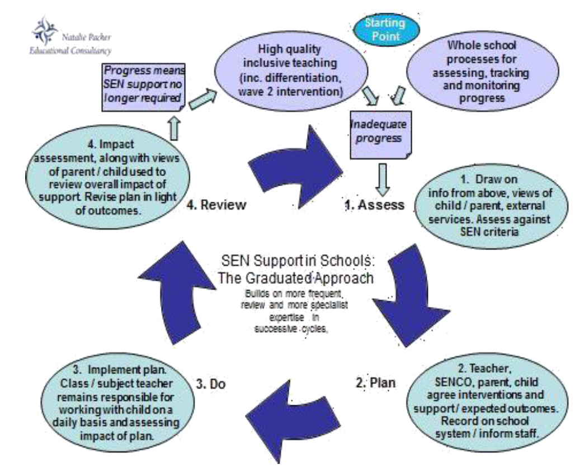

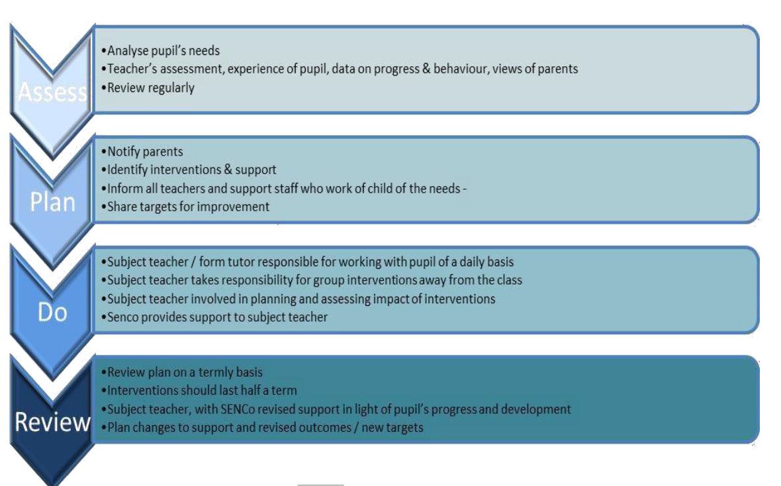

Section 5
Criteria for exiting the SEND register
The SEND register is reviewed every January and June. Depending on why the pupil was placed on the SEND Register initially, the following criteria are used to assess the appropriateness of on-going support:

- The concerns identified upon transition from previous settings are no longer evident
- Since baseline assessments, students have made progress and their attainment is now closer to age related expectations
- A pupil’s disability or difficulties no longer hinders their progress academically, socially and/or developmentally

All of this is looked at in the context of the child. For example, a child may now be progressing quicker due to additional support or interventions that the school has put in place and if that support is removed, progress may slow again. All of this is done through the graduated approach and in consultation with pupils, parents and relevant professionals. If a child is removed from the SEN Register, there are whole school processes which continue to monitor their attainment and progress. These are overseen by class teachers, Progress Leaders, the Senior Leadership Team and the Principal/Headteacher.

If a child is removed from the SEND register, this does not automatically exclude them from any additional examination access arrangements (reader, scribe or extra time).

Section 6
Supporting pupils and families
A child's education is a partnership between parents and teachers and we encourage regular communication between home and school. The progress that pupils make is shared with parents in line with our reporting cycle and also through Parents' Evenings.

If a child has complex needs, they may have an Education, Health and Care plan (EHCP). Parents/carers will be invited to contribute to a formal annual review to discuss their child's progress and be involved in deciding the next steps.

Parents are encouraged to arrange an appointment to discuss their child's progress with their class teacher, Phase Leader, or the SENCo. Please contact the school office who will arrange this appointment for you. The contact number is 01536 512204. Parents are also invited to open evenings, SEN Surgery, Coffee Afternoons and school celebrations with regular opportunities to come into school.

Some pupils are assessed during Year 6 to see if they qualify for access arrangements. This enables additional support during year 6 SATs to be given if required, such as a scribe, a reader, brain breaks etc should the Phase Leader decide this meets the criteria from the Department for Education (DfE). These access arrangements are reported as per the requirements set out by the DfE.

Other useful information:

- The arrangements for admission into Hawthorn Primary School can be found here:
Hawthorn Primary - Statutory Information & Policies (hawthornprimarykettering.co.uk)

- Northamptonshire local authority have a SEND local offer that can be accessed here
https://www.northamptonshire.gov.uk/councilservices/children-families-education/send/local-offer/Pages/default.aspx

- The Policy for Supporting Children with Medical Needs can be found here:
Hawthorn Primary - Statutory Information & Policies (hawthornprimarykettering.co.uk)

Section 7

Supporting Pupils with Medical Conditions

The school recognises that pupils at school with medical conditions should be properly supported so that they have full access to education, including school trips and physical education. Some children with medical conditions may be disabled and where this is the case the school will comply with its duties under the Equality Act 2010.

Some may also have special educational needs and disabilities (SEND) and may have an Education, Health and Care Plan (EHCP) which brings together health and social care needs, as well as their special educational provision and the SEND Code of Practice (2015) is followed.

Medicines can be administered in school with parental permission in accordance with our school policy. If your child has significant medical needs, you will need to make an appointment to speak to our SENCo, to discuss how we can best support your child.

Supporting Pupils with physical and mental health needs who are unable to attend school

Some complex and/or long-term physical and mental health issues may be considered disabilities under equality legislation. The local authority is responsible for arranging suitable full-time education for children of compulsory school age who, because of illness, would not receive suitable education without such provision. The local authority should be ready to assume this responsibly when a child has been unable to attend school for 15 days or more due to ill health. The school will maintain links with the LA to support pupils who are unable to attend school long term because of ill health. The school will share information to ensure the provision offered to the pupil is as effective as possible in providing continuity and consistency, and that it accounts for any special educational needs.

When the pupil is able to return to school, the school will work with the local authority to create a bespoke reintegration plan that will allow the pupil to adjust to school again. Some pupils will need gradual reintegration over a longer period. The reintegration plan should allow the pupil to address any gaps in learning that may have arisen during their absence. The school will also make any reasonable adjustments to assure the pupil’s access.

Where a pupil’s absence is planned, such as in the case of treatment or hospitalisation, the school will work with the local authority, hospital school or other provider and contribute to the child’s personal education plan.

Awarding bodies will make special arrangements for children with permanent or long- term disabilities or learning difficulties, and with temporary disabilities, illness and indispositions, when they are taking public examinations. The school will submit applications for special arrangements to awarding bodies as early as possible, incorporating any advice and information from those providing education to the pupil out of school.

Academies will only remove a pupil who is unable to attend school because of additional health needs where:
- the pupil has been certified by an approved medical officer as unlikely to be in a fit state of health to attend school, before ceasing to be of compulsory school age, and;
- neither the pupil nor their parent has indicated to the school the intention to continue to attend the school, after ceasing to be of compulsory school age.

Section 8
Monitoring and evaluation of SEND
In September, provision for each child will be carefully mapped to enable individual needs to be met. Pupil Profiles will be written or updated in June of each year, in preparation for transition. Children will also have Intervention programmes planned and these will be recorded on a child’s Individual Education Plan (IEP). These will be reviewed and amended each half term and shared with parents. Parent and child voice will be gained in December, April and July. The progress of students with SEND will be monitored termly at pupil progress meetings and provision altered or amended to meet the needs of each child.

The SENCo will write and maintain a development plan that will focus clearly on improving outcomes and provision for SEND students. The Headteacher and senior leadership team will closely monitor progress against this plan.

The school will appoint a governor with responsibility for SEND. That governors will be responsible for making sure the necessary support is made for any child who attends the school who has SEND. The SEND governor will have regard to the code of practice when carrying out their duties, liaising with the Principal/Headteacher, SENCo and staff. The Principal will ensure the Governing Body are kept up to date about any issues in school relating to SEND.

Section 9
Training and resources
Hawthorn Primary School receives an additional amount of money to facilitate educational provision to meet children's needs. This is called the ‘notional budget’. If a pupil with SEND needs additional educational provision, the local authority can be asked to provide top up funding, known as Early Help Locality Funding.

Some students with an Education Health and Care Plan will be allocated a personal budget. A personal budget is a sum of money made available by the Local Authority because it will not be possible to meet the child or young person's learning needs from the high needs funding made available to schools. It can be used to arrange and pay for some of the support agreed in the child or young person's Education, Health and Care plan.

Hawthorn Primary School recognises the need to train all staff on SEND knowledge and strategies. We aim to keep all school staff up to date with relevant training and developments in teaching practice in relation to SEND. We operate the following programmes:

- Extensive induction programme for new staff
- Regular, compulsory CPD through the inset days and the after school cycle of training
- Calendared, voluntary CPD sessions

The SENCo, along with the senior leadership team, ensures that training is matched to the school priorities as identified through the whole-school action plan.

Section 10

Roles and Responsibilities

All teachers are teachers of pupils with SEND and they provide high quality teaching which takes account the individual needs of pupils with SEND. Teachers are responsible for:
- Checking on progress and identifying, planning and delivering additional help that a child may need
- Ensuring that the SEND policy is followed in their classroom

Every school has a Special Educational Needs Co-ordinator who is responsible for managing and coordinating all aspects of Special Educational Needs and Disabilities within the school. The SENCo is responsible for:
- Coordinating the support for pupils with SEND and developing policy and practice to make sure all children’s needs are met
- Reviewing and updating the SEND Register and making sure children’s progress and needs are recorded
- Providing support for teachers and support staff in school so they can help children with SEND in the school make the best possible progress

Ensuring that parents / carers are:
- Involved in supporting their child’s learning
- Kept informed about the support their child is getting
- Involved in reviewing how they are doing

Hawthorn Primary School operates a team of Teaching Assistants who support children with SEND. They are line-managed by the SENCo. They are responsible for:
- Facilitating additional support to students where quality first teaching strategies are not fully enabling students to progress
- Supporting strategies to ensure that SEND students are making progress in line with their peers
- Acting as readers or scribes in public examinations
- Acting as a key worker to update pupil specific SEND data
- Providing the additional support as outlined in Education, Health and Care plans

The SEND governor is responsible for:
- Making sure the necessary support is made for any child who attends Hawthorm Primary School who has SEND.

Other useful information:
- The Designated Teacher with specific Safeguarding responsibility is Frances Martin
- The member of staff responsible for managing LAC is Frances Martin.
- The member of staff responsible for managing EAL students is Frances Martin.
- The members of staff responsible for meeting the medical needs of pupils are Frances Martin, Jo Marshall and Jane Aitken.

Section 11

Information management and storage
Pupil Profiles are working documents therefore teachers need regular access to SEND data. These are stored in a secure location where other children cannot access them but adults employed by the school and deployed to work with the identified children can access this information easily.
More detailed and personal documents are held by the SENCo in a secure location.
Section 12
Reviewing of policy
The SEND policy will be reviewed annually to ensure it complies with all current legislation and guidelines set out by the Government. If changes are required, the reviewed and amended policy will then be passed to the Trust Board for discussion and approval.
Section 13

Accessibility

When a pupil joins Hawthorn Primary School, any concerns around their ability to access the site, educational provision or learning are discussed with the pupil, their parents, teachers and other relevant professionals. Facilities currently in place are:
- The school site is wheelchair accessible
- Disabled parking spaces and toilets are available.
- Hearing loops are in place, in some areas, for hearing impaired pupils.

More details can be found on our accessibility plan, which is available here: Hawthorn Primary - Statutory Information & Policies (hawthornprimarykettering.co.uk)
All children, if required, can have access to a variety of resources such as pen/pencil grips, coloured overlays, highlighters and visual prompts on desks and classroom walls. Additional aids such as writing slopes and spellcheckers are available as necessary. Alternative forms of recording are encouraged such as mind maps, oral presentations and the use of ICT (including iPads).
Individual needs can be discussed with the class teacher or SENCo. If needed, we ask various outside agencies to help with assessing the needs of pupils to ensure they are able to access the school and learning to the best of their ability. Advice from Occupational Therapists, Physiotherapists, Health and Safety personnel at County Hall alongside the Specialist Teaching Service is sought to enable this to happen.

Section 14
Dealing with complaints
The SENCo, class teacher, Principal/Headteacher and SEND Governor can be contacted to discuss any concerns that you have as a parent / carer. Wherever possible, we seek to discuss with parents and come to an agreement about children's education. The school's complaints policy is available here:
Hawthorn Primary - Statutory Information & Policies (hawthornprimarykettering.co.uk)

Section 15

Bullying
As an education provider we take the steps to minimise the risk of bullying of vulnerable learners within our school. The Principal/Headteacher and senior leadership team supported by a behaviour team oversee the school’s anti-bullying policy and are responsible for ensuring that it is implemented effectively throughout the school. The safeguarding and well-being of all pupils within the school is the upmost priority of all staff.

A copy of the school anti-bullying policy can be found here:

Hawthorn Primary - Statutory Information & Policies (hawthornprimarykettering.co.uk)

A copy of the school safeguarding policy can be found here:
Hawthorn Primary - Statutory Information & Policies (hawthornprimarykettering.co.uk)

